CHAPTER 1

INTRODUCTION

A HRMS (Human Resource Management System) is a blend of structures and techniques that partner human resource the board and information advancement through HR programming. A HRMS may change a workplace. The administrator self-affiliation module draws in specialists to request HR related data and play out some HR trades over the structure. Specialists may request their interest record from the structure devoid of asking the in sequence from HR staff. The module furthermore allows managers to support O.T. desires from their subordinate from side to side the structure without over-loading the errand on HR office.

Various affiliations have gone past the standard limits and finished person resource the officials in sequence system, which carry enlistment, assurance, enrolling, work game plan, execution examinations, laborer advantage examination, prosperity, prosperity, and security, while others facilitate a redistributed hopeful after structure that incorporates a split of the earlier mentioned.
HRMS (HR The board System) is an overall organizations provider passing on development - driven business game plans that assemble the key goals of our regulars. We pass on unmatched business motivation to patrons from end to end a mix of methodology brightness, value frameworks and organization movement improvement.
We made plans to position property into new development and headway which offers a broad extent of composed programming. We create in the zone of Publicizing, Getting ready, Business Assignments and Development.
We continue setting the standard of making clients productive and helping them comprehends the open entryways that exist inside their affiliations. We achieve our guarantee to their thriving, locks in
people and relationship to give advantage by making amazing instinctive associations.
  - General Introduction

A HR the administrators organization (HRMS) or HR information structure (HRIS) is a sort of (HR) programming that unites different systems and strategies to make sure the basic organization of HR, business methodology and data. HR writing computer programs is used by associations to join different critical HR limits, for instance, securing delegate data, regulating payrolls, selection frames, benefits association, and observing investment records. It ensures standard HR shapes are sensible and simple to entrée. It merges HR as a request and, explicitly, its crucial HR behavior and methods with the in sequence advancement field, while the encoding of data getting ready systems formed into standardized timetables and packs of enormous business resource orchestrating (ERP) programming. By and large, these ERP structures have their start from programming that arranges in order from diverse application into single comprehensive database. The relation of its cash related and someone supply module through one database is the most basic capability to the solely and only made precursors, which makes this article application both unbendable and multifaceted.
Human resource information structures give a strategies for getting, securing, examining and flowing information to various stakeholders. HRIS engage improvement in ordinary methodology and update key decision making. The flood of imaginative progress has changed every one and all space of life today, and HR totally was not left flawless. Early systems were confined in degree, consistently revolved around a single task, for instance, improving the fund methodology or following agents' work hours. The present structures spread the full scope of endeavors related with HR workplaces, including following and improving method viability, regulating various leveled dynamic framework, and adjusting cash related trades of grouped kinds. Along these lines, as the activity of HR workplaces stretched out in multifaceted nature, HR development structures progressed to fit these necessities
The example of modernizing fund and workforce the officials frames began in the midst of the 1970s when due to obliged advancement and brought together server PCs, associations were at the same time contingent upon manual section to lead agent appraisal and to digitize reporting.[citation needed]
The essential endeavor resource masterminding (ERP) system which facilitated HR limits was SAP R/2 (later to be superseded by R/3 and S/4hana), introduced in 1979. This structure gave customers the probability to join corporate data ceaselessly, and control shapes from a singular brought together server condition. A critical number of the present popular HR systems still offer noteworthy ERP and account functionality.

The first absolutely HR-centered abuser server classification for the undertaking publicize was PeopleSoft, released in 1987 and later acquired by Prophet. (In the UK 'Inclination' was released by CIHR in 1903 as a gave HR The board Structure). Encouraged and revived by trade, PeopleSoft replaced the concentrated server condition thought and got a giant predominance that ensured it on the prospect for quite a while to move toward. The structure is so far unique today, while Prophet has in like manner developed different near BPM structures to modernize fundamental corporate operations.
Beginning in the late 1990s, HR vendors started offering cloud-encouraged HR answers for make this advancement continuously open to pretty much nothing and remote gatherings. As opposed to a client server, associations began using on the network accounts on electronic doorways to get to their specialists' execution, and track accomplishments paying little notice to their location.
The beginning of 2000 indicated another and positive thought in HR progression. A consistently expanding number of structures were dealing with unequivocal errands, for instance, selection or points of interest association, including best of breed systems that replaced the one-gauge fits-all ERP + HR condition.
In 2015, HR programming customers became more acquainted with gamification advancement to be explicit structures that associate a drawing in estimation to standard HR exercises, and energize specialists to perform better by conceding them with recognizable pieces of proof and bonuses.
Another pervasive improvement related to specific HR systems is video utilizing, as most providers embed web conferencing contraptions in their things, empowering boss to discover and attract capacities without geographical limitations.
Later on, HR the board writing computer programs is depended upon to go over its capacity, bolster profitability with continuously redid and confident driven enrolling, aerodynamic interface, and motorization of more HR associated methodology that are at present performed physically.
The account module robotizes the remuneration methodology by get-together data on delegate time and cooperation, figuring distinctive discoveries and forces, and delivering irregular checks and laborer charge reports. Data is generally empowered from the HR and timekeeping modules to discover modified store and manual check creating capacities. This module can wrap all specialist related trades similarly as join with existing fiscal organization structures.
The time and interest module collects regulated time and business related undertakings. The most excellent modules give wide versatility in data gathering methodologies, work movement capacities and data examination features. Cost examination and viability estimations are the basic limits.
The focal points association module gives a structure to relationship to control and track specialist enthusiasm for preferences programs. These routinely wrap security, compensation, advantage sharing, and retirement.
The HR the board module is a section covering various other HR viewpoints from application to retirement. The system records crucial measurement and address data, assurance, getting ready and improvement, limits and aptitudes the administrators, pay masterminding records and other related activities. Driving edge structures enable to "read" applications and enter noteworthy data to material database fields, prompt supervisors and give position the officials and position control. Human resource the board work incorporates the enlistment, position, evaluation, pay, and improvement of the delegates of an affiliation. At first, associations used PC based information systems to:
•produce checks and account reports;
•maintain staff records;
•pursue capacity the officials.
Online selecting has ended up being one of the basic procedures used by HR divisions to accumulate potential plausibility for available positions inside an affiliation. Capacity the board systems, or enlistment modules, offer a consolidated utilizing answer for HRMS which usually include:
•analyzing work drive use inside an affiliation;
•identifying potential hopefuls;
•recruiting through association going up against postings;
•recruiting through web selecting goals or circulations that market to the two spotters and competitors;
•analytics inside the enrolling technique (time to utilize, wellspring of agreement, turnover);
•compliance the board to ensure work promotions and contender onboarding seeks after government rules.
The gigantic cost procured in keeping up a dealt with enlistment effort, traverse general or industry-express occupation sheets and keeping up an engaged introduction of availabilities has offered climb to the improvement of a gave competitor following system (ATS) module.
The arrangement module gives a system to relationship to oversee and pursue agent planning and improvement attempts. The structure, customarily called a "learning the administrators system" (LMS) if a free thing, empowers HR to adhere to guidance, capacities, and capacities of the laborers, similarly as portraying out what instructional classes, books, Smaller plates, electronic learning or materials are available to make which aptitudes. Courses would then have the capacity to be offered in date unequivocal sessions, with delegates and getting ready resources being mapped and directed inside a comparable structure. Current LMSs empower managers to underwrite planning, spending plans, and timetables near to execution the administrators and examination estimations.
The delegate self-organization module empowers specialists to address HR related data and play out some HR trades over the system. Laborers may scrutinize their interest record from the system without asking the information from HR staff. The module furthermore allows chiefs to confirm O.T. requests from their subordinates through the structure without over-loading the errand on HR division.
Various affiliations have gone past the customary limits and made human resource the administrators information systems, which support selection, decision, acquiring, work position, execution assessments, specialist advantage examination, prosperity, security, and security, while others arrange a redistributed applicant following structure that encompasses a subset of the previously mentioned.
The examination module enables relationship to expand the estimation of a HRMS execution by expelling HR related data for use with various business information stages. For example, affiliations join HR estimations with various business data to separate examples and irregularities in headcount in order to all the almost certain anticipate the impact of agent turnover on future yield.
There are by and by various sorts of HRMS or HRIS, some of which are generally adjacent machine-based programmin
  - Problem Statement

The Human Resource Management System will keeps an eye on the Automation of the Performance of the Employees as regard to what is seen on them. Their execution would accord the qualities of what they're managing. On the present condition, the execution of the delegates were ineffectually surveyed and watched beforehand, in the midst of and after each season of their occupations. In spite of the way that HR divisions would evaluate them, it is an ideal thing for them to accomplish every appraisal of agents regularly to revive their execution and their inclination of work

Something different is various associations on our days have battle on giving their delegates authentic rewards on the hard works they produce for the welfare of the association, so the structure should need to make a possible response for this by the evaluation of the computerization of the execution examinations of the agents, their prizes would depend upon their execution rate as what may be communicated by what may be their assessments in their motorized execution rating in the system. This would be the reason of their compensation rewards at whatever point a laborer have a high evaluating act, he/she could get remunerates on explicit occasions as given by higher specialists of the association
As per this, their motorized execution rating could in like manner be used if a specialist is subject for a headway. This would completely based their task from what the HR Department would post about their execution. The higher the rating of the execution, the higher believability that particular delegate would be enlist first for a headway that, clearly, would be from the higher organization of the association. Also, this bit of the
- Training
- Performance of employees
- Bonuses depends on employees performance rate
- Promotion of employee
- Seminars
- Eligibility
- Leave
- Attendance
- Office of the employees
- Salary Bill Generate
  - Existing System
There are no force structures that is associated in the Quezon City Hall they were using manual methodology, for instance, paper works for getting ready and execution of the agents, so the examiners needs to develop the Human Resource Management System to make their work basic.
Flow society is portrayed by an extending necessity for explicit foundations in various fields of development for the execution of their ordinary limits similarly as research and consultancy work. These associations require fast access to abstract appropriated information. Presentation, the techniques for limit and dissipating of information are advancing brisk, so no library can store every single conveyed datum and can outfit profitable organizations with its old manual exercises.

This is the season of computerization, yet in the meantime show manual working system exists in Quezon City Hall especially in assessing the delegates for their readiness and execution, . In the plan of progress of getting ready and execution system is acclimatized to PC condition in consistently ordinary similarly as information amassing and recuperation. Motorization to an increasingly essential degree can reduce weight of evaluation for the planning and execution remaining main job. It also shields from work weight and shortcoming. It not simply offers beneficial organizations and opens another period in bibliographical control yet offers access to required database in the close-by government unit, for instance, Quezon City Hall.

The HR Administration comes up short concerning controlling the employee'sactivities in researching his/her characteristics and inadequacy. The decisionfor examination of naming next assignment to the agent or to trainhim/her to improve the aptitudes – where lies with genuine projection. Heis not gave the low down endeavor information done or to beassigned subject to Application/Verticals

Process Model of Existing System Contributing to the Problem
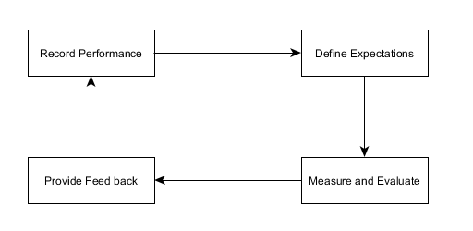
Figure 1.1 Process

Model of Existing Appraisal System

  - Objective of the Work
As we go further gathering all the information and conducting interviews, we came to understand the fact that in the near future user/client will tend to request what changes would they want to happen. City of Personnel Officers (CPO) also known as Human Resource was quite remained to apply old tradition way of system. Even though they had existing system with them they still endeared into the system what they learned and from this we assure that this system could benefit enough for them to cater all of their transaction regarding to Employee.
  - Proposed System with Methodology
Human Resource Management System is a system based module under Human Resource Department. It is a system basically perform the automate evaluation process and management of all Employees Daily performance. It used to monitor the performance of a certain Employee if he/she was doing his/her job in order and in a proper way. This also serves as a basis of information for the department to conclude if that certain Employee was eligible enough to grant Bonuses or to be promoted.
The Scope of this system was listed below:
- Employees Performance Appraisal
- Caters the Salary bonuses of Employee
- Hold the Promotion of a certain Employee
- List of Seminar conducted by the Department

  - Feasibility Study

Once the problem is clearly understood, the next step is toconduct feasibility study, which is high-level capsule version of theentered systems and design process. The objective is to determinewhether or not the proposed system is feasible. The three tests of feasibility have been carried out.

Technical Feasibility

Economical Feasibility

Operational Feasibility

TECHNICAL FEASIBILITY

In Technical Feasibility study, one has to test Whether theproposed system can be It is planned to implement the proposed system using javatechnology. It is evident that the necessary hardware and softwareare available for development and implementation of the proposedsystem. Hence, the solution is technically feasible.
ECONOMICAL FEASIBILITY
As part of this, the costs and benefits associated With theproposed system compared and the project is economically feasibleonly if tangible or intangible benefits outweigh costs. The systemdevelopment costs will be significant. So the proposed system iseconomically feasible.
OPERATION FEASIBILITY
It is a standard that ensures interoperabilityWithout stifling competition and innovation among users, to thebenefit of the public both in terms of cost and service quality. Theproposed system is acceptable to users. So the proposed system isoperationally feasible.

CHAPTER 2

REVIEW OF LITERATURE

2.1 Review Summary
A time-consuming process most of the forms are incredibly long and time-consuming. As a result, some managers routinely recycle “last year’s” evaluations. If HR is required to sit in on the sessions, the amount of wasted time increases significantly. That’s why employees must go overtime to finish their paper works. Explain to employees how the organization invests time and effort in professional development. Performance evaluations are not intended to be punitive rather, the purpose of evaluating job performance is to uncover strengths, identify weaknesses and work on striking a balance between the two. In an article published in "Public Personnel Management," contributor Gary Roberts cautions managers to remember the intent of performance evaluation is to provide helpful feedback. Train your supervisors and managers on how to conduct performance appraisals that instill pride in individual accomplishments and contributions to the company.
Employers that provide regular feedback generally get high approval marks from their employees. Workers feel good about managers who are genuinely appreciative of employee efforts, even if it's just an informal "thanks for your hard work." With supervisors and managers who understand the importance of feedback, you can maintain a work force that is energized to achieve high work execution. Giving contribution on just a yearly reason will when all is said in done spotlight basically on the most recent accomplishments. But in the event that there is a technique for following execution reliably, only a fragment of a specialist's accomplishments are evaluated in the midst of the examination.

High pressure in light of the way that the technique is so enthusiastic and no benchmark execution numbers are set early, powerlessness can cause various agents irregular measures of anxiety weeks before the method. Chiefs may in like manner be anxious in light of the weakness related to a laborer's reaction. I realize one agent who truly figured she would have been ended going before her examination anyway ended up being the most vital assessed specialist in the gathering. Laborers should have an exact idea of their assessment some time before any social affair is reserved.

Regularly boss erroneously rate solitary agents to set aside some money or to shield laborers from getting the opportunity to be evident for progression. Some whimsically give a score just underneath that required for a lift in pay, while others give scores essentially over the point where they would be required to make disciplinary move. With the objective that laborers react in this issue.

Evaluating agents to help their motivation in their work is a best practice to inspire them. That is the reason they ought to have a mechanized structure to rate their agents base on their cooperation, work hours and accomplishments.

A dreary technique most by far of the structures are amazingly long and monotonous. As needs be, a couple of executives routinely reuse "last year's" evaluations. If HR is required to sit in on the sessions, the proportion of tarried increases generally. That is the reason delegates must go extra time to finish their paper works. Uncover to delegates how the affiliation puts time and effort in master improvement. Execution evaluations are not proposed to be remedial rather, the inspiration driving surveying work execution is to uncover characteristics, perceive deficiencies and work on striking a concordance between the two. In an article dispersed in "Open Personnel Management," contributor Gary Roberts alarms executives to remember the desire for execution evaluation is to give pleasing analysis. Train your boss and managers on the most capable technique to lead execution examinations that imbue pride in individual accomplishments and responsibilities to the association.

Consistently boss misleadingly rate solitary specialists to set aside some money or to shield agents from getting the chance to be clear for progression. Some boastfully give a score just underneath that required for a lift in pay, while others give scores basically over the point where they would be required to make disciplinary move. With the objective that agents react in this issue.

Assessing agents to help their motivation in their work is a best practice to energize them. That is the reason they ought to have a mechanized system to rate their agents base on their interest, work hours and accomplishments.

CHAPTER 3

SYSTEM CONFIGURATION

3.1 Hardware requirements

Content | Description
HDD | 20 GB Min  40 GB Recommended
RAM | 512 GB Min  1 GB Recommended

Content Description

3.2 Software requirements

Content | Description
OS | Windows XP with SP2 or Windows  Vista
Database | MS-SQL server 2005
Technologies | Node Js Angular Js with Rest Api
IDE | VS Code
Browser | Google Chrome, IE

CHAPTER 4

MODULE DESCRIPTION
4.1Admin(HR)

Admin(HR) can admission all the information of an worker departments etc. and he can right to use or modifies the each worker data.
Getting Started with HRMS
Three frequently used icons in HRMS:
View Icon
Edit Icon
Delete Icon
pattern Wizard
design Wizard allows you to put together setting that reflect necessities single to your institute and make your purpose all set to use. Wizard is the first display that is display if you have logged into the purpose for the extremely initial time. Wizard enable you to enter the essential information that makes your submission ready to add employees to your business right away.
Set up design Wizard
Information is gathered in 5 steps. The first is the Modules section.
a. All of the modules are appeared round depiction
b. Snap on the module image to impact it to incite or dormant
c. Snap on Save to apply the movements made
d. Snap on Next to proceed to the consequent stage In the Site Config territory, all of the countries, their states and urban zones are appeared as per usual so as to connect with the application head to organize the rules.
e. Make changes to the Site Configurations reliant on your affiliation tendencies
f. Snap on Add Time Zone to incorporate the required time zone In the Organization region, give affiliation information
g. Snap on Add State to incorporate the required state
h. Snap on Add City to incorporate the required city
I. Snap on Add Country to incorporate the required country
j. Enter the information of the relationship After saving your affiliation's nuances, an ADD catch will appear on the upper right corner of the course of action wizard screen. In any case, it isn't required to incorporate a delegate in this movement, you can even incorporate a laborer after the entire structure is done.
The principle delegate you incorporate (Employee #2) will be the pioneer of the affiliation. Note: You can simply incorporate distinctive delegates consequent to including the Head of the Organization. On clicking Add Employee the underneath screen will appear:
k. Enter the all the required nuances
l. Position can be orchestrated later
m. Occupation title can be structured later
n. Come back to the structure wizard and resume masterminding your application The accompanying region is Business Units, this is the spot the forte units and divisions can be made.
o. Make another forte unit by giving its name and street address.
p. Make another office inside the claim to fame unit
q. Incorporate another division (To have various workplaces under a claim to fame unit The last region in plan wizard is Service Request.
r. Make another organization class
s. Make another requesting type
t. Incorporate another sales type Click back to come back to the application site and leave the plan wizard. Note: Ensure that you always in the wake of entering nuances in all aspects of the Configuration Wizard and at precisely that point proceed.
Setting up the Dashboard:
HRMS dashboard engages you to have every one of the information you need at first. You can pick what segments you need on the dashboard by masterminding contraptions. You can in like manner see your partners' best in class birthday updates and revelations for an office/forte unit from your organization.
You can organize your devices on your dashboard using the underneath procedures:
a. Snap on the affiliation logo in the upper left of the header
b. Snap on Click here association in the Dashboard board in the left side
Or on the other hand
c. Snap on marked in customer's name in the upper right of the header
d. Snap on Settings in the dropdown
Or then again
e. Snap on Settings image in the base left corner of the page (Common for all)
f. Select Widgets get in the settings page
g. Natural the picked menu item(s) in the contraptions box
h. Snap on Save to incorporate Widgets in the Widgets sheet
Announcements can be made by the Super Admin, Management and HR. The statements will appear on every customer's dashboard.
a. Snap on 'Relationship' in the top menu
b. Snap on Announcements
c. Snap on Add
d. Select the business unit(s), division and title
e. Exchange associations at whatever point required
f. Snap on Post to circulate the statements
Add an External User
a. Snap on HR in the top menu
b. The left side board will demonstrate the submenus
c. Snap on Manage External Users under User Management
d. Snap on Add get in the right side board
e. Snap on Configure Identity Codes to incorporate the character code for customers
f. Enter the Full Name
g. Enter the Email
h. Select a vocation in Assign a Role dropdown
I. Give comments if critical
j. Snap on Save to incorporate an external customer
Download Import Format
a. Snap on HR in the top menu
b. Snap on Employees submenu on the left side board
c. Snap on Import Format interface over the laborer nuances structure on the right side to download the arrangement
d. For further course, click on the Help interface
4.2 Employee Management
In this module purpose HR has to register the new employee details into the database.
In this module the HR has to register the employee details based on the requirements and it consist of a categories data such as personal details , Address, Qualification, Reference and HR.
HR Data is mandatory for an employee to register a details of an job code, salary code, leave code has been mentioned by HR
Add an Employee
Social affair Management Details is an imperative part of an association. Utilizing HRMS, getting the administration subtleties is basic. Endless supply of the application out of the blue, the administration subtleties are obtained directly before adding workers to the association. (This is as of now done in the 'Include Employee' alternative in the arrangement wizard)
Note: Only after the administration subtleties are accumulated and the principal worker (Head of Organization, Employee #2) is included, the benefit to add representatives to the application will be empowered.
a. Snap on Human Resources in the top menu
b. Snap on Employees submenu on the left side board
c. Snap on Add catch in the correct side board
d. The Employee ID will be auto created by the application
e. Enter the subtleties separate to the representative
f. Snap on Save to include the worker
Set Employee Configurations
a. Snap on Human Resource in the top menu
b. The left side board will show the submenus
c. Snap on the Employee Configurations in the submenu
d. Snap on the Add catch on the correct side board
e. Enter the required subtleties
f. Snap Save catch to spare the subtleties

Update My Details
a. Snap on Employee Self-Service in the top menu
b. Snap on My Details in the submenu on the left side board
c. In the correct side board, click on Add to include the Contact Number
d. In the popup, enter the Contact Number
e. Snap on Ok to add the Contact Number to My Details
Snap on the ideal tab in the correct side board to include or alter subtleties
f. Snap on Edit in the particular screen to include or alter the subtleties
g. Snap on Save to include or refresh the subtleties

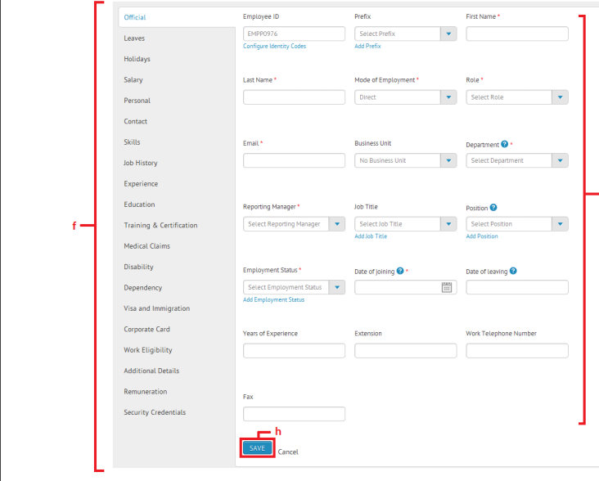

Include Employee Documents

All the basic records relating to a representative can be made accessible in HRMS. These archives are included by the representative, HR and super administrator. The directors can see the archives of their colleagues
For workers to include archives:
a. Snap on Self Service in the header

b. Snap on My Details in the left side menu
c. Snap on Document
d. Snap on New Document
e. Enter the Document Name
f. Snap on Save to spare the subtleties
g. These archives can be altered, erased and downloaded
Arrange Tabs for Employees
a. Snap on HR in the top menu
b. The left side board will show the submenus
c. Snap on Employee Tabs
d. Snap on Edit catch to arrange tabs for workers
e. To empower explicit tabs for workers, check individual checkboxes regarding wanted tabs
f. To empower every one of the tabs for workers, "Check All" checkbox
g. Snap on Save to spare the progressions
4.3 Department Management
In this module it carries out the list of department where employees are working and that the employees need to report their specified leaders about the job.
It consist of different type of job descriptions and salary code this will be handled by HR for providing a job to an employee based on provided department and can specify the annual income salary for the job types etc.
Include Departments
a. Snap on Organization in the top menu
b. The left side board will show the submenus
c. Snap on Departments
d. Snap on Add catch on the correct side board
e. Enter the essential subtleties
f. Snap on Save catch to spare the Department
Include an Organization
a. Snap on 'Association' in the top menu
b. The left side board will show the submenus
c. Snap on Organization Info
d. Snap on Click Here connection in the correct side board
e. Enter the required subtleties
f. Transfer your association logo
g. Snap on spare subsequent to filling in every one of the subtleties.
Include Business Units
a. Snap on Organization in the top menu
b. The left side board will show the submenus
c. Snap on Business Units
d. Snap on Add catch on the correct side board
f. Snap on Save catch to spare the Business Unit
4.4 Attendance Management
This module purpose is it maintain the attendance of an employee which gloss’s the salary based on attendance.
By providing a records into the biometric the employees attendance are to be stored on a backend(mongoDB) database. Based on the attendance it automatically generates employee salary. In this module the hr can see the day by day attendance or monthly attendance of an employee.
4.5 Salary Slip Management
Based on the employee attendance our company provides a salary. The employees can access their salary slip by specifying required data into an application & they can downloadTheir salary slip
It is based on the attendance of an employee he has been already generated different types of department salary code based on the employee id the salary amount will be generated.HR can handle monthly wise if dedication or allowances can be inserted to the employee based on the performance an employee. This salary voucher can be generated has a bill record(PDF file) downloadable.

View & Generate Reports
a. Click on Analytics in the top menu
b. You will be redirected to Analytics page where graphical representation of organization statistics are displayed
c. Click on a menu item in the Analytics menu
d. Click on the corresponding submenu
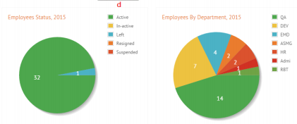
e. In the selected submenu page, click on Export to PDF or Export to Excel to generate report
f. Provide the specifications required to generate report
g. Click on Generate Report to generate a custom report
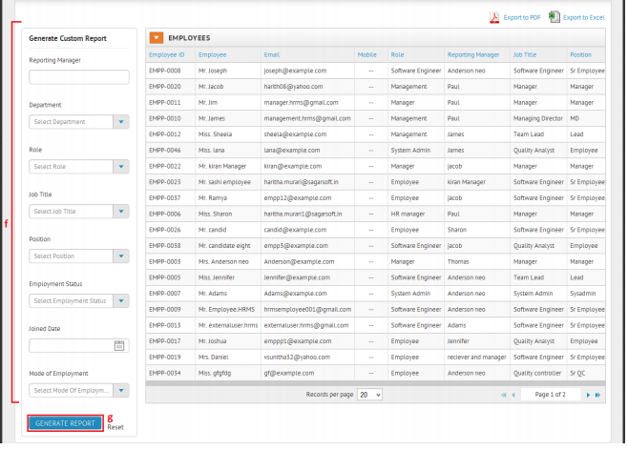
View Activity log
a. Click on Logs in the top menu
b. The left side panel will display the submenus
c. Click on Activity log
d. View the logs of all the activities in the right side panel
e. Click on View Record to view the modified record.
View User log
a. Click on Logs in the top menu
b. The left side panel will display the submenus
c. Click on User log
d. View the logs of all the users in the right side panel
CHAPTER 5
SYSTEM DESIGN
5.1 DFD/ UML Diagrams

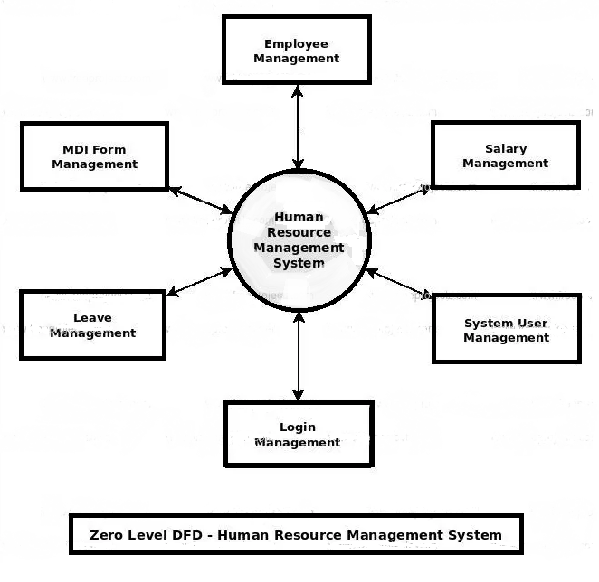

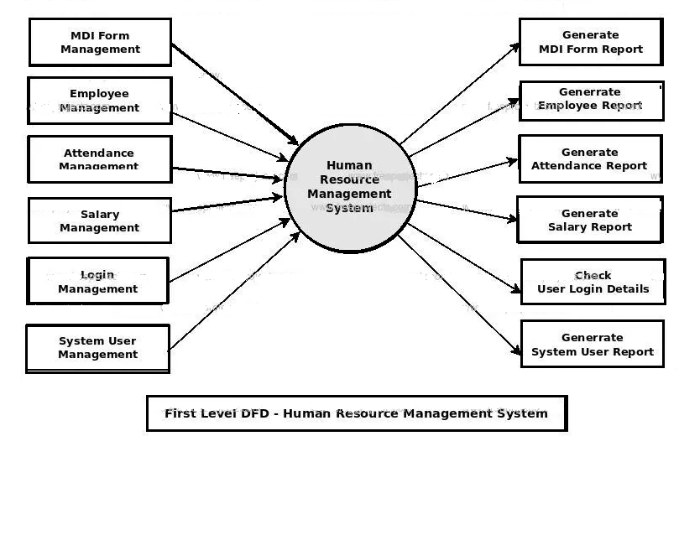
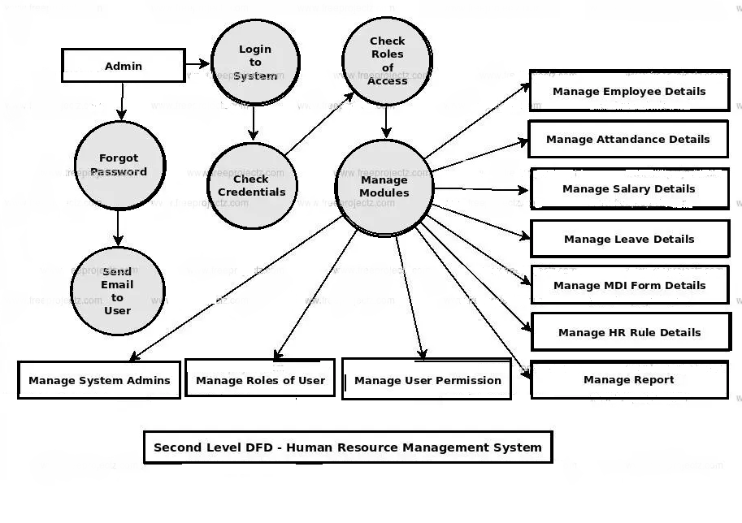

5.2 Data Base Design

Data Description of Authentication and Authorization Module
In this section all authentication and authorization module database tables will be described in details. We describe each table and its responsibility in the module. Each authentication and authorization database tables keep many fields related to the specific data object. Relationship between each table will be explained as well.

    - TBL_APPL_User
    - TBL_APPL_User_Resp
    - TBL_APPL_Resp
    - TBL_APPL_Resp_Form
    - TBL_APPL_Form

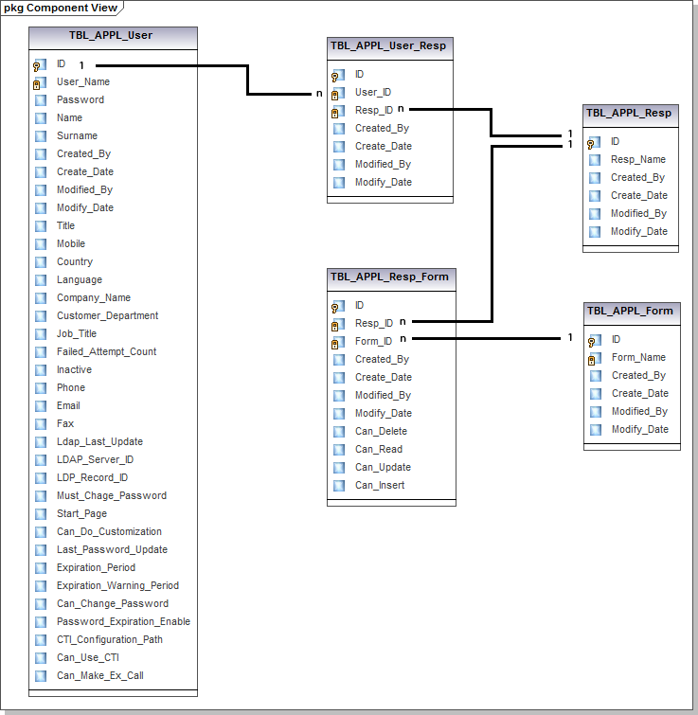

Data Objects

TBL_APPL_User

Name: | TBL_APPL_User
Description: | User application table is used for determining user information. When a user logs into the HRMS, user’s username and password is checked from this table and directed to the system. Also it contains other data fields such as user id, name, surname, when this user is created and modified by whom, title of the user, password history, phone, email, fax, and many more.

TBL_APPL_User_Resp
Name: | TBL_APPL_User_Resp
Description: | This table is basically used to determine the assigned role types for a user. It also keeps creation and modification dates, and id of the users who created and modified these role assignments.

TBL_APPL_Resp

Name: | TBL_APPL_Resp
Description: | This table is responsible for storing role type lists. The data fields are basically role id, role name, people who created and modified and when.

TBL_APPL _Form
Name: | TBL_APPL_Form
Description: | This table stores a list of functions that are used in the application. The basic data fields are function id, function name, creator, and modifier.

TBL_APPL_Resp _Form

Name: | TBL_APPL_Resp _Form
Description: | This is table is used as a bridge between TBL_APPL_Resp and TBL_APPL_Form. By means of this table we can determine which role types are authorized to which sets of functions. That is why when a user is logged in into the HRMS; according to the user role type the interface will be displayed.

Relationships
The relationship between these tables is not prone to a single id. Nevertheless, there exists a process of checking a user at each step and determine his responsibility and authority. By the help of user id, user responsibility will be checked and interface will displayed according to the list of roles or responsibilities. After being checked the role types, related authorized functions will be called in the system.

Behavioral Model and Description

Description for software behavior
Each employee will be added to the system by entering the personal data of an employee by HR. At the creating state, HRMS will give an id to the newly added employee.
After being added by HR, each employee has a right to be introduced to the system by admin. At this state, admin determines the role type of the user and this user is given a password automatically.
At the entering state of the system, each user sees the same interface which asks a username and a password.
After entering state, each user sees the same interface with different tabs related to their role type/s (manager, HR, admin, employee). At this stage:
⇧ Managers can
Search employees under his responsibility or search all the users he/she desires, i.e a manager can search rows of the database.
Edit the employees' data who are under his responsibility.
Get report of information related to the employees he/she desires to learn, i.e. a manager can search columns of the database.
⇧ Employees can
Edit their personal data
see their data in editable form.
⇧ HR can
Search employees who has the properties he/she desires.
Get report about an employee, or employees.
Add employee by entering some specific personal data of that employee.
Edit employees' data
⇧ Administrator can
Edit any user' s (manager, admin, HR, employee) data
Add user, in other words create a valid account to login.
Edit role properties, for example there can be a need to change the attributes of each role type such that the type of tabs each user sees may change. For that kind of situation there may be need to change the properties of each role type.
Add a new role type to the system. Since, our HRMS is going to be a generic program there can be an addition to the role types and our system will perfectly welcome that kind of need.
Search the users who have the desired capabilities or properties specified.
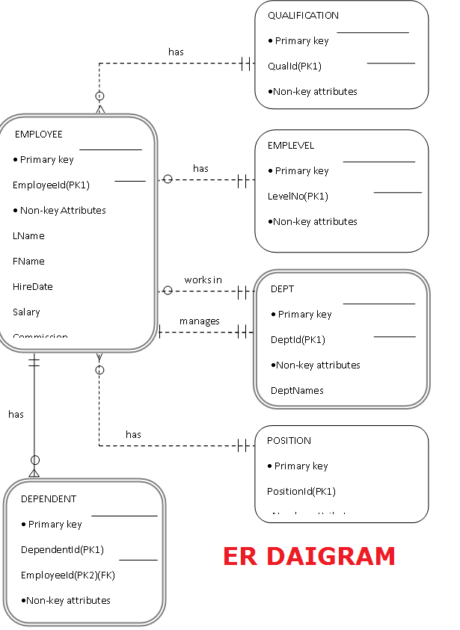

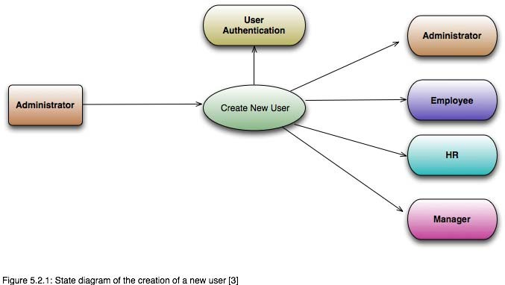
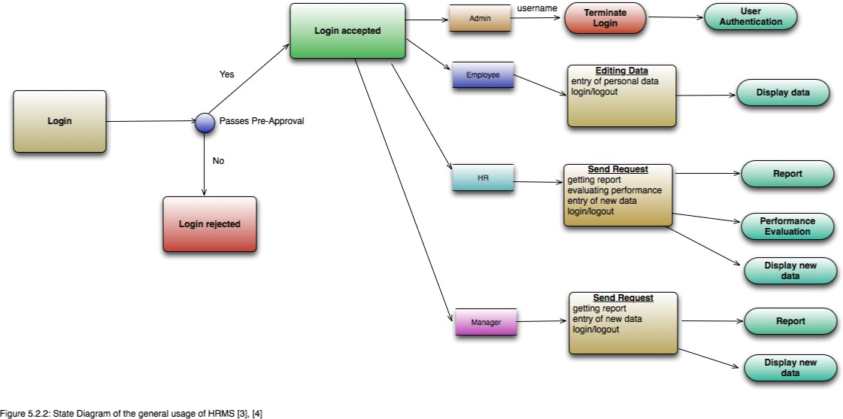

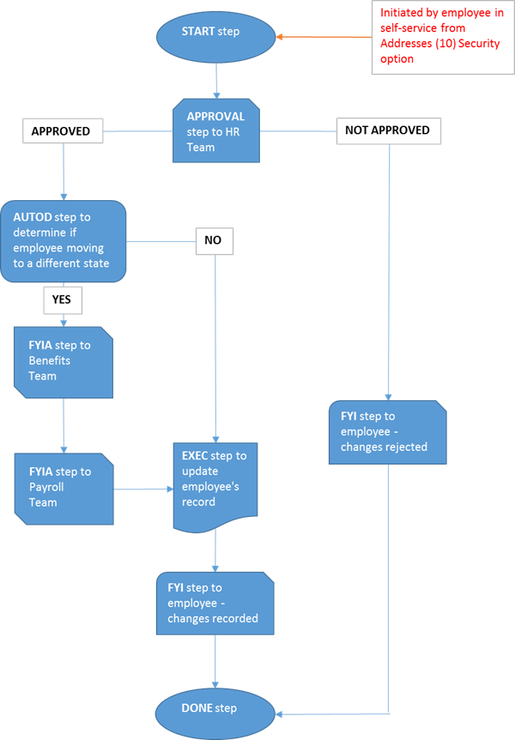
Flowchart
We should stroll through a fairly typical work process that could occur at any organization: a worker making a location change demand. Assume we have a speculative organization that utilizes a mix of frameworks to deal with these solicitations. The work process is begun by the worker and wrapped up by HR. This is the abnormal state breakdown of occasions:
The worker contacts HR and solicitations the location change.
The representative is given a paper structure on which to make the solicitation, which they should round out and return.
HR audits the returned structure and contacts the worker if extra data is required.
HR educates the Benefits office if the worker is moving to an alternate state.
Depending on the diverse expense codes, HR may likewise tell Payroll to change retaining charges.
HR refreshes the worker's record.
HR educates the worker their record has been refreshed.
Various "gotchas" go implied here; a location change is likely not a solicitation representatives make regularly, so some disclosure is required on their part to perceive how to start the solicitation. This requires some serious energy, regardless of whether it's only two or three minutes. The subsequent stage is rounding out the structure and returning it to HR—the representative may physically convey this to HR or output and email it. This adds to HR's weight of monitoring the solicitation since the structure could be coming through something like two distinct channels. When gotten, HR needs to audit the mentioned change. In the event that the representative is moving to an alternate state, they'll advise the advantages division so they can assess required changes. This opens up an extra correspondence way among HR and Benefits before the location change can be finished. These equivalent endeavors should likewise be copied among HR and finance. At that point, there are different entanglements—imagine a scenario in which HR can't peruse the worker's penmanship or the solicitation is missing data. They'll need to return to the worker and affirm. When the solicitation at long last comes to the heart of the matter where HR inputs it to the worker's record, this is the second time the information is being entered—it's conceivable the HR individual could make a grammatical mistake or misread the representative's penmanship and information the wrong data. The last can be particularly troublesome; when the representative's W-2 appears at the wrong location, who will be considered responsible? There's no compelling reason to make this rundown any more extended as you get the point: A ton of time can go to squander in an apparently straightforward solicitation.
The general issue with our speculative organization's procedure is that there's no single framework taking care of the solicitation. At the end of the day, it's hard to oversee demands and viably prop track of what's up on. So as to keep everybody engaged with the work process in agreement, the solicitation should be taken care of inside a solitary framework all the way.
The single framework, electronic variant of this work process would be streamlined as pursues:
The representative gets to the electronic framework and explores to their own data, where they input their location change and present the solicitation.
The framework courses the change solicitation to the assigned HR agent and educates them a location change is pending audit by means of email.
The previously mentioned HR staff part surveys the representative's solicitation and affirms or denies it.
The Benefits office is educated if the change demand is endorsed by HR and the representative is moving to an alternate state.
Due to conceivable duty suggestions, the Payroll division is likewise educated if the worker is moving to an alternate state.
The framework refreshes the worker's record and also makes, a record of the exchange, yet a record of the whole work process from beginning to end. The last incorporates subtleties of who was included, dates and times, and the real information part of the work process.
Finally, the framework naturally tells the representative about the status of their solicitation.
Not at all like previously, what goes inferred here is certain. The worker didn't sit around idly mentioning a structure from HR and rather got to their location by means of the electronic framework. When the worker presented their solicitation, the framework steered it to the proper faculty meaning the representative didn't need to realize where to send it. The framework is additionally dealing with doing the correlation with the worker's past location and deciding whether they're moving to an alternate state and, assuming this is the case, illuminating Benefits and Payroll. Proceeding, when the HR work force survey the change, there's no requirement for them to enter the information a second time; they can verify or refute the change without a second's pause. Except if the location required rectification, the change goes in precisely as entered by the worker. In conclusion, HR work force never again need to physically illuminate the representative about the status regarding their solicitation as that is additionally consequently taken care of by the framework.
On the off chance that you include the all out time taken by the single framework process, it's a small amount of the non-single framework process. In that lies the estimation of electronic/single framework work process: each time it's utilized, we spare X measure of time in respect to doing it the non-single framework way. On the off chance that we spare 20 minutes all things considered each time, the time rapidly includes and conflicts with the advancement time as quantifiable profit. Time is nevertheless one advantage—we additionally have the exchange records should we have to review the change sometime in the not too distant future. In conclusion, we decreased the general likelihood of mistake.
The All-Important Flowchart
As a work process planner, you will probably catch the majority of the subtleties of a given work process and make an interpretation of it into a flowchart so the procedure can be classified, comprehended, and enhanced. We're going to take the location change precedent and make a flowchart which will be the outline of a Vista HRMS work process.
(There are a wide range of flowchart devices accessible: Microsoft Excel, Visio, or even pencil and paper can be similarly as viable.)
Each progression in this flowchart is a Vista HRMS Workflow step type. A full rundown of these are accessible on the PDS Documentation site (https://techref.pdssoftware.com – sign in with your Support site certifications) > Back End > Workflow radio catch > Flow Step Types (Action Codes) segment. This guarantees a balanced interpretation of our flowchart into Vista HRMS. Two or three notes about our flowchart:
All Vista HRMS work processes will have a Start and a Done advance, which are placeholders to show the start and consummation of the stream.
Note the utilization of Teams, an authoritative component of Vista HRMS accessible in the Human Resourcesapplication > Setup Tables selector > Teams. Whenever the
workflow achieves a stage that requires human association, for example, Approval, just a single individual from the group needs to favor it before the work process pushes ahead.
•When the work process achieves the Approval step, an email is naturally conveyed to individuals from the HR group – there's no requirement for an extra FYI step heretofore.
•We're utilizing a FYIA (FYI with Acknowledgment) venture to the Benefits and Payroll Teams – an individual from that group must sign in to Vista HRMS and recognize the work process before it can continue. With regards to the general location change work process we're stipulating that by recognizing, Benefits and Payroll have made all the fundamental changes on their finishes to oblige the representative's solicitation.
Making Your Workflow HRMS
In Vista HRMS, you'll be making what's known as a work process format which will hold the majority of the work process ventures just as the Next Step interfaces that associate the means together; the last are spoken to by the bolts between ventures in the flowchart. The work process format, which is again the general meaning of your business procedure, is associated with Vista HRMS by means of a Workflow Security connect. The last tells Vista HRMS under which conditions the work process layout ought to be chosen.
You'll add your work process formats to Vista HRMS in the System Administration application by tapping the Workflow Templates interface. Snap the green add catch to include another work process layout. When you spare the format, you'll have the capacity to include ventures under the work process layout's Steps tab.
PDS proposals while making a work process in Vista HRMS:
•Always allude to your flowchart!
•Create your work process layout first and after that include the majority of your means in the request they're recorded on the flowchart.
•The names of every one of your Steps ought to be actually as they're named on the flowchart. The progression type (FYI, Approval, &c) ought to dependably be a piece of the progression's name for example "Endorsement venture to HR Team".

•When including steps, increase the Display Order under the General tab for each progression by 10 so the means are recorded in a similar request they're recorded on your flowchart.
•E-mail ought to be designed for any progression type requiring human connection (Approval, FYIA, and Decision). A default email will go out in the event that you leave the subject and body of the email clear.
•For each progression including human cooperation, set the Late Notice box under their General tabs – this is the timeframe that is permitted to slip by before a late notice is conveyed.
•Once you've included and designed every one of the means, go into each progression and make its Next Step link(s). You may need to allude to the previously mentioned PDS Technical Documentation site should you need to compose any rationale to make the work process course effectively, for example, for Auto-Decision steps.
•Link the work process to a Vista HRMS Security alternative by including a connection under the work process layout's Link tab (see last notes underneath). This ought to be done last.
•Always allude to your flowchart!
It's useful to print out your flowchart or put it on a second screen so you can without much of a stretch make every one of the means – recollect, the flowchart is outline of your work process.
We won't complete a well ordered to make the work process showed above in Vista HRMS since that goes past the extent of this article, however what you'll understand subsequent to making a Vista HRMS work process is that once the flowchart is finished, you've achieved 80 percent of the absolute work. The test is getting the flowchart made and everybody to concede to the procedure stream. While making your flowchart, odds are you'll need to lead interviews with representatives effectively associated with the procedure to perceive how it streams. This is a fantastic chance to improve the procedure and work in usefulness you might not have recently had, for example, programmed warnings and directing – once more, ask the representatives associated with the procedure how it truly functions and if there are issues with the present procedure.
Some last notes:
•Your work process doesn't need to be an unchangeable reality; it's conceivable that a month down the line, you need to include an extra warning or maybe simply change the late notice time frame. That is fine – you ought to dependably be attempting to improve your procedure. You can change your work process format whenever.
•When testing your work processes, practice every single imaginable way through the work process. To completely test the work process we appeared in this article, you'd need to submit two location change demands – one remaining inside the state and the other moving to an alternate state.
•Ensure that the majority of your work process testing members in Vista HRMS have distinctive email addresses.
•All Vista HRMS work processes will consequently store their exchange records in the work process history tables which are never erased by the system.TheHRMS Processing Monitor enables you to think back and survey any past work process.
Security Considerations
Vista HRMS work processes are associated with Security alternatives; this implies your Security setup will be a factor in your work process organization as authorizations to Security choices are doled out on a for each Security bunch premise. You'll need to have the capacity to respond to this inquiry: For which of my Vista HRMS Security gatherings will I be work process empowering a given Security choice? In our location change work process we may pick our Employee Self-Service and Manager Self-Service gatherings. On the off chance that you go to the acknowledgment that just a part of the individuals in a given Security gathering ought to utilize the work process, consider part up that Security bunch into various littler gatherings. Then again you could utilize the settings on the work process layout's Security connects to possibly disengage those representatives.
CHAPTER 6
SYSTEM IMPLEMENTATION

6.1 Implementation

6.1.1 Pre – Implementation Technique
In software engineering a system can be divided into multiple-layers either physically or logically providing a client-server environment known as n-tier architecture. The purpose of dividing the system is to provide a model for software developers developing flexible, reusable and more secure applications. 26 We applied 3-tier architecture in the development of our web application due to reliability, re-usability, flexibility and security. Making change in one layer has no efficient on other layers, so, less work is required for maintenance and error correction.
Three-Tier Architecture
A 3-tier architecture comprises of following layers :-

Presentation/Client Tier
Middle Tier
Data Tier

Presentation/Client Tier
This layer is on the top of application development hierarchy which enables a client to put some requests by putting a URL in the web browser or enter some data into a form. This layer fetches the results according to the request from the other tiers by communicating with them and presents it to the user.
Middle Tier
The layer that works as an agent between the data storage and presentation tier is known as middle tier. This layer also performs logical processing of the application and provides all the functions. In web applications, the middle tier consists of a web server which is responsible to get the request from client tier. It then sends it to data tier after doing appropriate processing on the request generated by the presentation tier, giving back results to the client tier.
Data Tier
In 3-tier architecture database server is considered as a third layer of the architecture. At this level data is stored and retrieved according to the requirements and requests sent by the presentation tier through middle tier.This layer is independent of other tiers due to which the performance and scalability of the system increases.
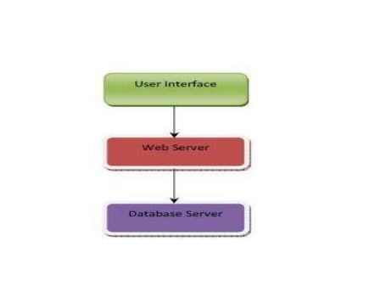

Three Tier Architecture of the System

Implementation of Three-Tier Architecture in the System

User Interface
It is easy to use and easy to understand user interface. User interacts with the web server through interface and performs different tasks like employee registration or salary calculation etc. Web browser is required to run the user interface.
Web Server
In our project apache is used as web server. Web server is used for secure communication between user interface and database server. Web server receives the request from client and sends them to the database. Similarly, it takes data from the database against the clients request and forwards it to the client.
Database Server
MySql server is used in this project to handle database operations. The client does not directly interact with database, rather it goes through web server in order to keep the database secure from an unauthorized access. It is also called a third tier in the three tier architecture as implemented in this project.
This section will describe how the system is implemented using different web techniques. Implementation of User interfaces
User interfaces are front end of any system with whom users interact to communicate with the system. There are two major users of this system that are team leaders and project managers. Hence we can divide the interface of our system into two major interfaces. Team leaders user interface and project managers interface. After login into the system the users of the system are able to view only their authorized section, i.e., a Team leader can access the employee registration, employee management and salary calculation interfaces only. Where as the project managers can access interface which generates different reports other than the access of team leader interface. Different web development techniques are used to develop and implement these interfaces such as XHTML, CSS, java scripting, ajax toolkit. With the help of these techniques we developed interactive and user-friendly interfaces.
Salary Calculation
Salary calculation interface is available for both team leader and project manager. This interface contains two drop down menus which are implemented using ajax. NODE JS code is used to fetch the data from the database after selecting particular employee from the list of employees that belong to a city which is selected from the drop down menu of city. After the fields filled out automatically the user can fill some fields manually that are optional such as allowances or deductions if any. NODE JS code is working behind the calculate button which will be activated and give result to user in response. After calculating the salary could be stored in the database or can be calculated again.
Drop Down Menus
All the drop down menus in the interfaces are generated dynamically using ajax and CSS. NODE JS and HTML code is used to implement these drop down menus which will interact with the database and fetch the required data from the database to drop down menus. 29
Form Validation
At user interfaces/front end of the system, different forms are available. The data entered into the fields of these forms by the users is validated by using the java scripting at the client side. After validation using the NODE JS code on client side interface, data is sent to the server side interface. Finally the data is sent to the database system to be stored. 4.7.5 File Handling Different kind of files are required to generate such as salary slips, bank files/invoices or tax file. These files generate on server side interface by using the NODE JS code. This code interacts with the database, gets the required data and fills out the fields of the form which is developed using ajax. This form is then converted into the files with .pdf extension and can be saved into the system and can be sent via email. The whole process is done with the help of NODE JS code.
6.12 Post – Implementation Technique
In this section we will describe how employee salary management system is functioning. This system will integrated with the client management system named as HRMS that is already functioning within the organization. Employee salary management system is a web based system so at the front end, users of the system can access different graphical forms which can only be filled by the authorized. The data is given as the input to the forms and after passing through certain query, it will check and processes the data and finally store it in the database which is working at back end of the system. And whenever the need arises the data can be fetched out from the database. This system calculates the monthly or hourly salaries of its employees on the basis of certain parameters. It is also capable of calculating the tax for the each individual and generate different kind of files, such as bank files or employee salary slips etc. Moreover, the system is able to calculate the total amount of salaries, social security and tax of all the employees in one city for each month. It is also capable of calculating the salary and social security payable by the organization for a whole year. It then calculates the total amount of tax payable by the organization for every year. All information is stored in the database of the system for the record of the organization and can be viewed any time it is needed.
Anatomy of the System
In this section we will explain the overall working of the system and functions. Each function will be discussed and explained individually as following: After Logging in to the system a welcome screen appears where the user can view all the functions that he can be performed under the heading Contents, such as, logout, employee registration, employee management, salary calculator, bank file, employee pay slip, employee salary report, company/city salary report. All these functions are explained below.
Login
As the user enters in to the system the login screen appears, The user can view all the employees in the form of a list of a particular city, by selecting the city from the list of cities. User can view some basic information such as, person number, first and last name. To view the detail information about a specific employee the user can go to detail information 37 page of that employee by just clicking on the view detail option. The user can also view the functions that he can perform under the heading contents.
Employee Registration
It is viewed by clicking on employee registration from the contents. This function is used to register a new employee. The user can store all necessary information such as, name, person number, address in detail, bank details, contact information, information about salary, tax, social security and the status of employment, in the database.
Salary Calculator
It is accessible through the salary calculator from the contents. The user will select an employee from the list of employees from a city. He will fill in necessary information i.e, working hours, allowances, deductions, percentage of the tax and some comments. This will be the input to the system and the output is provided by the system as soon as the user will click on the calculate button at the bottom.
Data Verification
In this form the employees belonging to a certain city can be viewed by clicking the drop down list of cities. The employees can be selected by clicking the check boxes and the data entered will be verified as soon as the verify button is clicked. It will be processed through the queries working and linked with the verify button.
Generate Employee Pay Slip
Once a city is clicked from the drop down list, the list of all the employees can be accessed. The user will select an employee, a month and fill-in the year to generate the pay slip. As soon as the user clicks, generate pay slip button, the system will run some quires. After doing some final checks the output is generated in the form of pay slip. 40 Rest button is used to reset the form so that the pay slip for another employee can be generated.
Employee Salary
It contains all the necessary information such as, employee name, address, person number, working hours, organization name and number, total salary per month or per hour before tax, amount of tax, salary after tax and date of transfer of salary. The salary slips will be sent to the employees.
Employee Salary Report
All the data about an employee including salary information and salary history is available by clicking on the employee salary report. As soon as the user clicks the submit button, a report regarding an employee arises on the screen. The report includes the personal information, salary, tax and bank details as shown in figure 4.18. The report also shows a detailed history of the employee salary, tax information, social security for a whole year and for the previous months as a track record stored in the database of the system.
Company/City Salary Report
User can access the company or city salary report form by clicking on the company/city salary report as shown in figure 4.19. The user can select either the organization or can select a city from the drop down lists. Certain quires will run as soon as the submit button is clicked and a report is generated. This report includes the details of the salaries, total amount of tax and social security paid by the organization for the whole year such as year 2017 and year 2018 and for each month in a year as shown in the results.

6.2 Screen Shots
SignUp

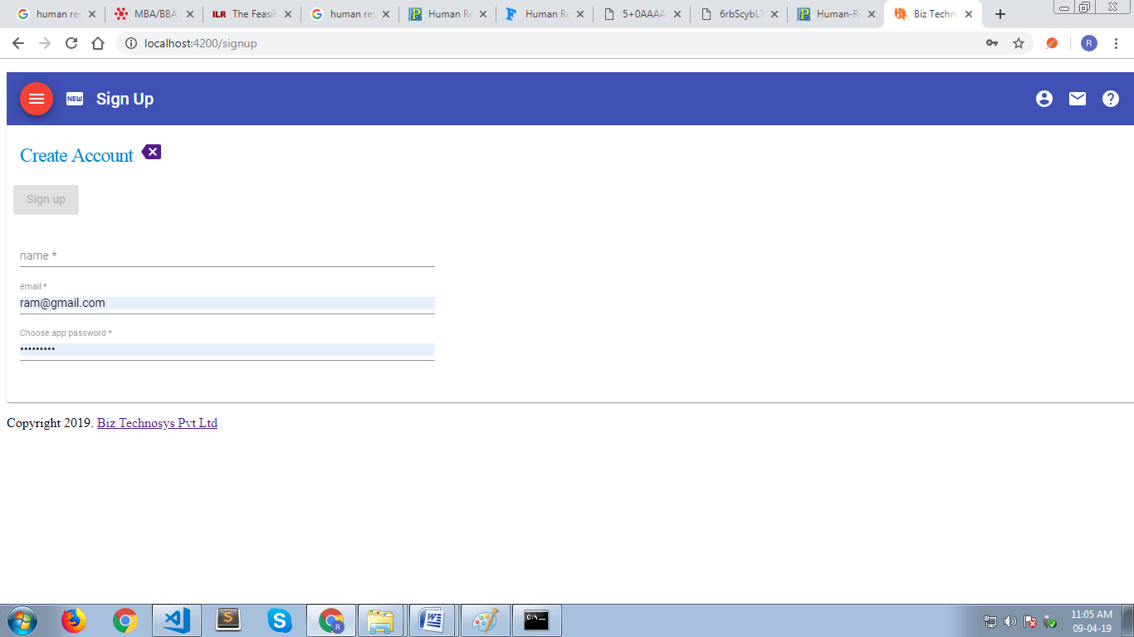

Login

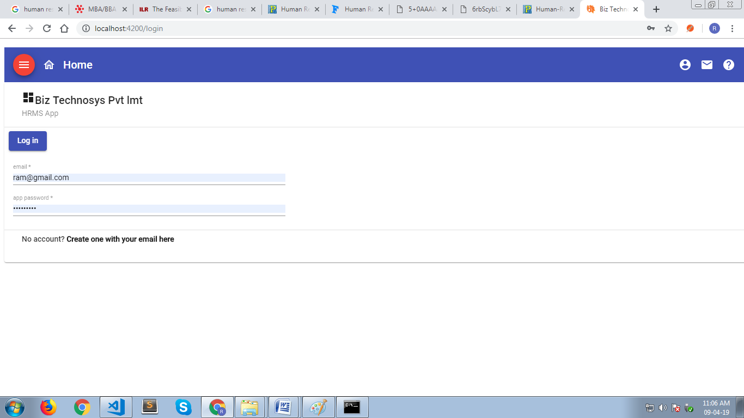
Update Password and Profile

Setup Job Code

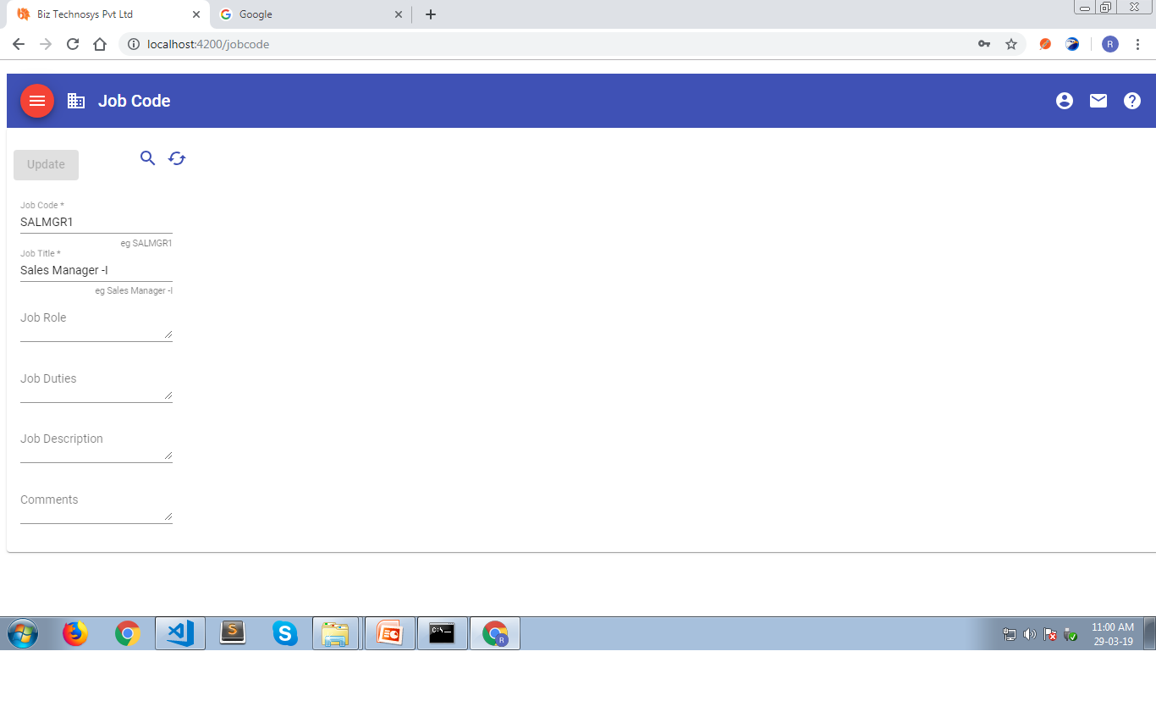

Setup Salary Code

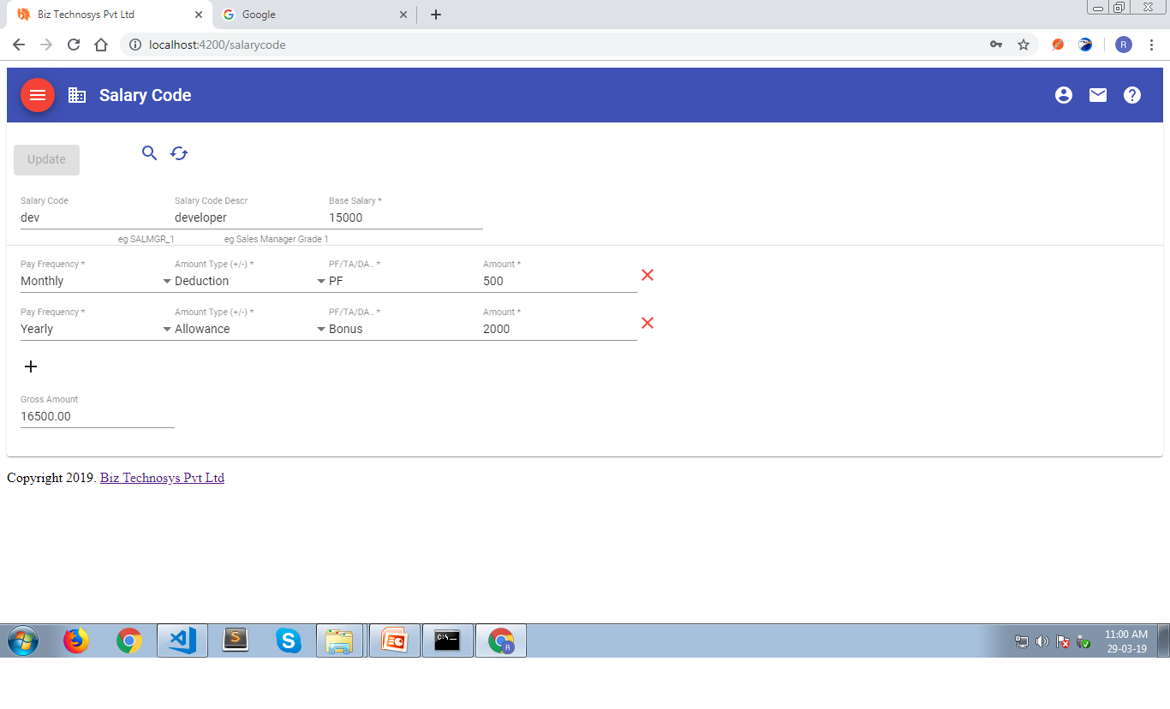
Setup Leave Code

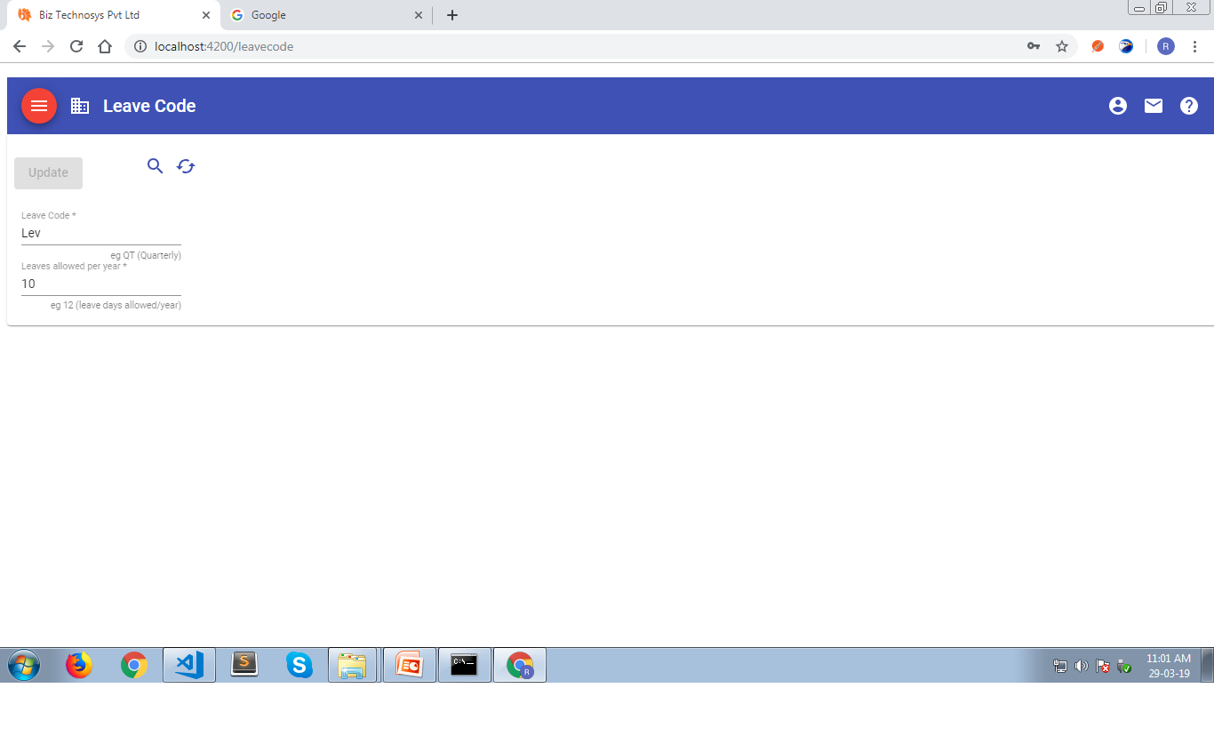

Employee Registation

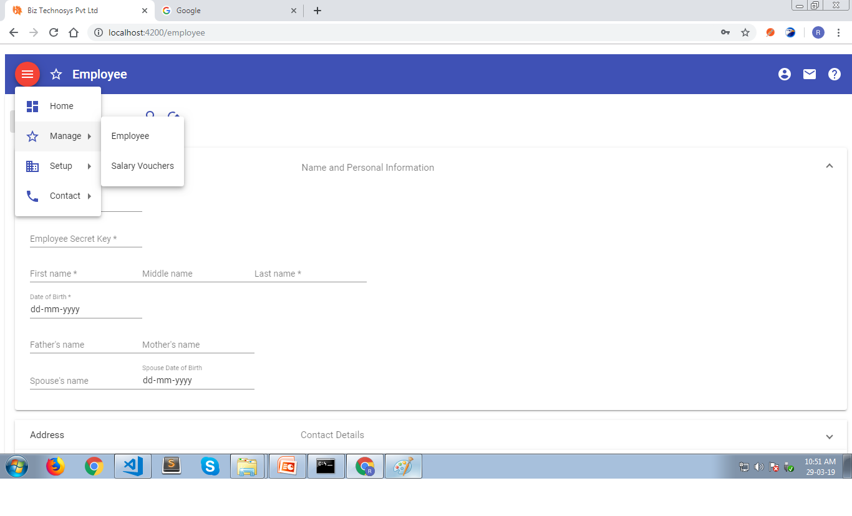

Salary Voucher

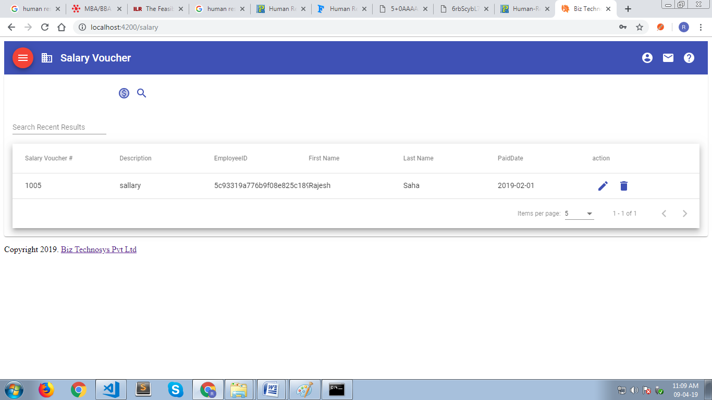
Top of Form

Salary From

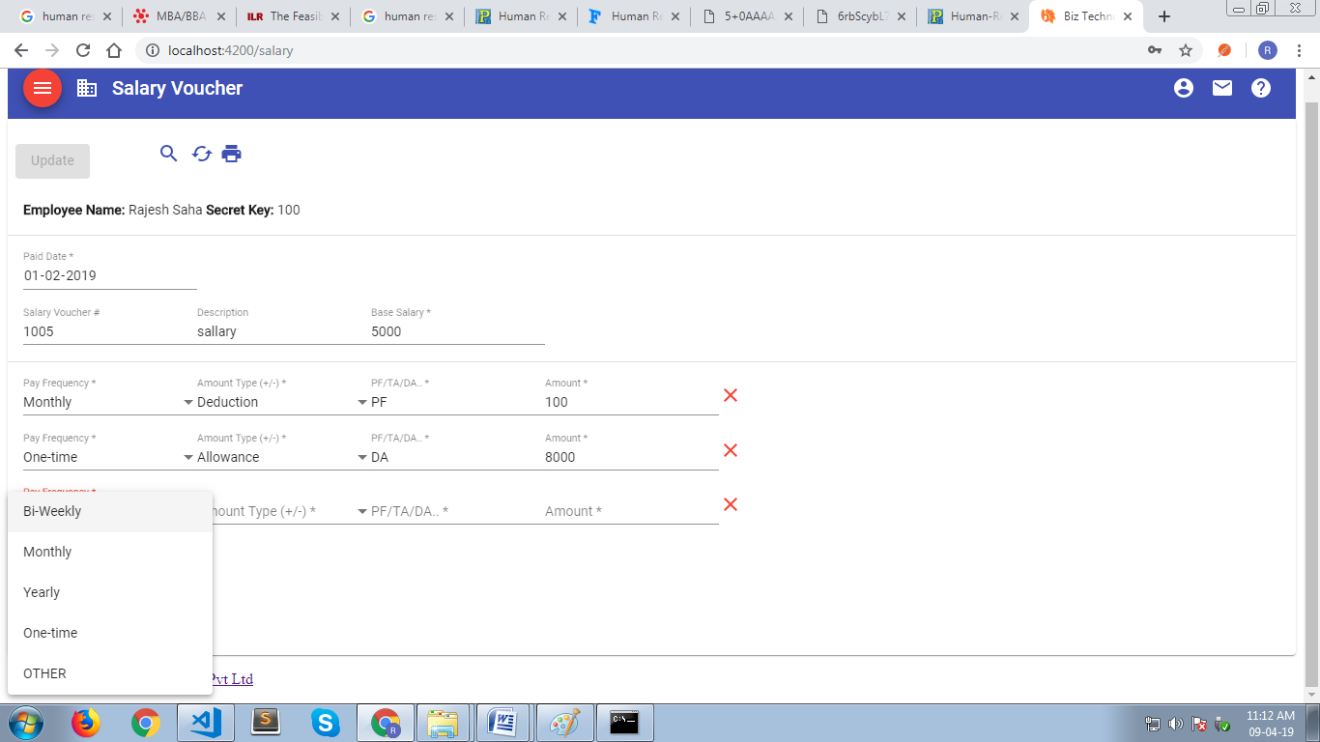

Salary Bill Print

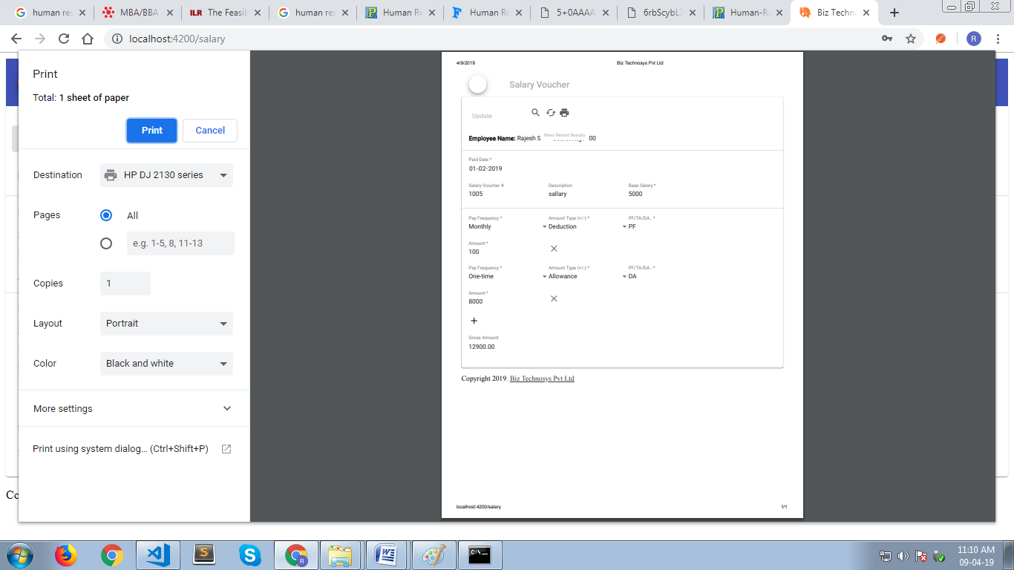
CHAPTER 7
SYSTEM TESTING

The Process Model means the design, testing and implementation of the project. This is also known as Classic Life Cycle Model or Linear Sequential Model or Waterfall Model. It includes various phases and activities. The activities are as listed below in the following manner:

System Analysis and Design:

Easy track is based on waterfall model of software engineering. In “WATERFALL MODEL”, the process software development is divided into separate process phases. Software design, implementation, testing and maintenance. All these phases are cascaded to each other so that second phase is starts as and when defined set of goals are achieved for the first phase and it is signed off. So the name is suggested as “WATERFALL MODEL”.
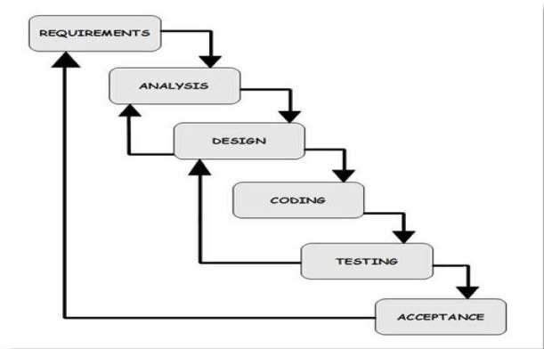
General view of a “WATERFALL MODEL” is given below,
The stages of “WATERFALL MODEL” are requirement of the system to develop are captured in this phase. Requirements are the set of functionalities and constraints that the end-user (who will be using this system) accepts from the end-user. The requirements are gathered from the end-user by consultation these requirements are analyzed for their validity and the possibility of incorporating the requirements in the system to develop is also studied.

Finally, a requirement specification document is carried which serves the purpose of guidelines for the next phase of the model. It is called as Software Requirement Specification (SRS).

System and Software Design:

Before starting to the actual coding of any project, it is highly easy to understand what we are going to create and what it should look like? The requirement specification from first phase is studied in the phase and the system design is prepared. System design helps in specifying hardware and system requirement and also helps in defining overall system architecture. The system design specification serves as input for the next phase of the model.

Analysis:
The overall code of software in larger system is identified during system engineering. However it’s necessary to take a harder look at the software’s role to understand the specific requirements that must be achieved to build high quality software. That’s the job of software requirements analysis.

The requirement modeling activity for a system c/s from the analysis modeling methods applied to more conventional computers architectures because analysis modeling avoids specification of implementation detail issues associated with the allocation of software components of client and server are considered as only as transaction made to design. However, an evolutionary approach to software engineering is applied for c/s system. Implementation decision on over all c/s approach may be made during early analysis and design iterations.

The steps involved in analysis include data; functional and behavioral requirements begin identified by electing information from the customer. Requirements are refined and analyzed to access their clarity, completeness and consistency. A specification incorporating a model of software is created and then validated.

Analysis has a set of operational principles which are as follows:

- The information domain of a problem must be represented and understood.

- The functions that the software has to perform must be defined.

- The behavior of the software must be represented.

- The models that depict information function and behavior must be partitioned in a manner that uncovers detail in layered fashion.

- The analysis process should move from essential information towards implementation detail.

Requirement Analysis:

Requirement analysis is software engineering task that bridges the gap between the system level requirement and software design. These activities result in the specification of the software operational characteristics indicate the software interface with other systems elements and establish constraints that the software must meet.

7.1 Test Cases
i. Validation for empty ID field:
If the ID field is empty then display a message box— ID Field Empty.
ii. Validation for empty Password field:
If the Password field is empty then display a message box—
Password Field Empty.
iii. Validation for mandatory field:
If the mandatory field is empty then display a message box— Field
marked mandatory cannot be blank.
iv. Validation for Email field:
If the Email field is not valid then display a message box— Invaild Email.
v. Validation for Employee code field:
If the code entered is already present in employee table then
display a message box— Code already exists.
vi. Validation for Project code field:
If the code entered is already present in product table then display
a message box— Code already exists.
vii. Validation for Attendance code field:
If the code entered is already present in attendance table then
display a message box— Code already exists.
viii. Validation for Department code field:
If the code entered is already present in department table then
display a message box— Code already exists.
ix. Validation for Employee leaves:
If the leave entered is more then total number of leaves display a
message box— Leave is unapproved.
x. Validation for Month Selection:
If the selection of month is not made display a message box—
Please select proper month.
65 | P a g e
xi. Validation for Mobile Number:
If the mobile number is not of 10 digits then display a message
box— Please enter proper number.
xii. Validation for Skills:
If the code entered is already present in skills table then display a
message box— Code already exists.

Form Name | Test Case | Test Data | State | Test Input Value | Expected Result
Login Form | User name and password is correct | User name and password correct | Valid | Admin and  ***** | Will allow to enter into main form
Employee Add Form | Mandatory fields fill, text values, numeric values field fill properly | All fields filled properly | Valid | Numeric fields, Text fields | Accurate Employee data saved in database
Project Add Form | Mandatory fields fill, text values, numeric values field fill properly | All fields filled properly | Valid | Numeric fields, Text fields, email ID fields | Accurate Project data saved in database
Designation Add Form | Mandatory fields fill, text values, numeric values field fill properly | All fields filled properly | Valid | Numeric fields, Text fields, email ID fields | Accurate Designation data saved in database
Required Skills Form | Mandatory fields fill, text values, numeric values field fill properly | All fields filled properly | Valid | Numeric fields, Text fields, email ID fields | Accurate required skills payment data saved in database
Employee Attendance Form | Mandatory fields fill, text values, numeric values field fill properly | All fields filled properly | Valid | Numeric fields, Text fields, email ID fields | Accurate Employee Attendance records saved in database

7.2 Maintenance
This software manages company’s employee details and applications such as attendance details, employee leaves, Employee skills, department and many more.

It provides the Manager with effective tools to keep track of the records and easily manipulate them.

The software has wide scope in the future as its vast calculation of salary earnings and deduction.

In future it can be enhanced with some more features like:
  - Distributed systems.
  - External modules like TDS.
  - Extra modules like overtime.
  - Full financial accounting system.
  - A complete payroll software.

CHAPTER 8

RESULTS AND DISCUSSIONS

8.1 Conclusion
In Grid environment, the resources are heterogeneous and geographically distributed with varying capacities, usage and constraints. The management of resources and job scheduling in such large and distributed environment is a complex task. We have developed an architectural resource management framework called Grid Management Information Server (GMIS) to address this complex task. To support the thesis, that an efficient grid resource management system can deliver a significant value to users as compared to traditional approaches, we have:
• Identified key requirements that an efficient resource management system that needs to support.
• Identified important design considerations for efficient resource management system.
• Compared with the traditional resource management frameworks.
• Identified and included several features not available in the other popular resource management frameworks.
• Developed a distributed resource management framework called Grid Management Information Server (GMIS).
• Designed resource discovery algorithms with three different strategies i.e., dynamic, event based and user based discovery.
• Developed monitoring and data collection manager services to provide users with wide range of options to select resources based on their capabilities and historical performance.
• Developed push and pull based algorithms for gathering resource information, to ensure that the grid users will have latest status about the resources as well as submitted jobs.
• GMIS provides support for activation graph creation based job submission and execution i.e., submitted jobs can be divided into multiple tasks and results can be analyzed at each task level. 154
• Shown how GMIS can be used as distributed computing environment over a WAN for UH Multidisciplinary Design Optimization framework.
• Demonstrated how a virtual cluster can be formed using GMIS.

This document states the design level approach taken by the InnovaSoft Team for the project HRMS. After giving a basic information about what the HRMS is, the document briefly describes the problem and the solution we proposed to the problem with the figures to visualize better and steps taken to solve the problem. In other words this document introduces the technical details of the HRMS.
In the first part of the technical design, the major functions needed to develop an HRMS are introduced. Later on, these major functions and their sub-functions are visualized with the use case diagrams. In the second part, user interfaces are described in a detailed manner with figures. Lastly, data modules and their relationships are discussed.
To conclude, this document constitutes a base for the development of an HRMS.
Grids have evolved rapidly and are becoming a good alternative for the otherwise costly supercomputers. The tools and number of applications being built around these technologies are also increasing day by day. The resource management in grid environment is a complex task, because resources are distributed over wide area network and dynamic nature of resource availability. The resource management systems used in grid environments need to be adaptive so that they can handle dynamic changes in availability of resources and user requirements. At the same time, they need to provide scalable, controllable, measurable, and easily enforceable policies for management of the resources. To address these requirements, a resource management framework called Grid Management Information Server (GMIS) has been developed. The GMIS provides dynamic discovery of resources, monitoring of resources and brokerage service. Since the GMIS framework is a component based architecture implementation can be easily done for different middleware technologies.
The information services used in grid environments need to be highly flexible in nature to handle the dynamic behavior of the grid network resources. Additionally, they need to be scalable and easily implement able in grid based environments. The GMIS framework addresses these requirements. Several features and design considerations in GMIS framework are not available in the other popular frameworks. The GMIS framework describes the resource management for grid environment that supports resource discovery, monitoring and brokerage with integrated topology information. This frame work is an open and extensible resource monitoring system, based on the Client - Server Architecture. The GMIS prototype is developed and efforts are currently underway to develop complete services.
The criteria set for goals is to generate files, deliver on time, performance and efficiency issues of the system. The major goal we have achieved is to generate the bank files/invoices for the banks with salary information so that the banks are able to transfer the salaries of the employees into their accounts. After developing the system, we calculated the salary and generated a bank file. The bank file was then sent to the bank and was practically done successful(see section 4.9.7). To check the performance and efficiency of the system we used the WAPT 7.1 tool. It is a load, stress and performance testing tool for web sites and web applications. We created basic testing scenarios and hence got some meaningful results shown in figure 5.1.These results are showing that this web application is efficient and performing very well.
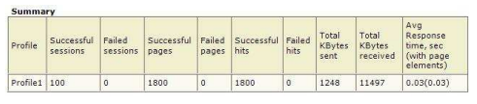
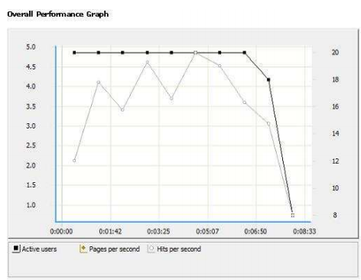

Our target was to deliver the system by the end of October 2017. Whereas, we finalized it by 15th October 2017 and delivered well on time. The system we developed is more customized and specifically designed according to the requirements of our client and is able to integrate with the existing HRMS system to form one complete computerized system for the organization. The system is able to calculate employees salaries according to certain parameters, such as age. It is also able to generate specific files for the organization such as employee salary slips and bank files. The system is also able to calculate tax payable by the organization on the basis of certain formulas provided by the tax authorities according to the Swedish law. It generates and sends tax files to tax office, moreover, the system is more cost effective as compare to other salary management systems. As this system is integrated with the existing system so does not need new resources to run the system. Therefore, it is easy to handle single system
8.2 Limitations
The foremost research limitation is on the subject of the industry perspective. The research study was restricted to those respondents who wish to respond to the questionnaire; therefore future research might focus on a generously proportioned sample of respondents, in order to validate the results of the study. Other limitation is the static nature of the study, that is, the study is based on the existing scenario of the level and usage of HRIS; but HRIS can be enhanced in future. Consequently, same research can be conducted in future to know whether HRIS is improving with changing time or not. Other limitation is that the questionnaire survey may endure with the reaction bias.
1. correlation analysis A measure of the relationship or association between two continuous numeric variables that indicates both the direction and degree to which they co-vary with one another from case to case, without implying that one is causing the other.
2. cross sectional study Cross-sectional studies form a class of research methods that involve observation of all of a population, or a representative subset, at one specific point in time. . 3. Deductive Reasoning Deductive reasoning, also deductive logic or logical deduction or, informally, "top-down" logic, is the process of reasoning from one or more general statements (premises) to reach a logically certain conclusion. Deductive reasoning links premises with conclusions. If all premises are true, the terms are clear, and the rules of deductive logic are followed, then the conclusion reached is necessarily true. 189
4. Empirical research Empirical research is a way of gaining knowledge by means of direct and indirect observation or experience. Empirical evidence (the record of one's direct observations or experiences) can be analyzed quantitatively or qualitatively. Through quantifying the evidence or making sense of it in qualitative form, a researcher can answer empirical questions, which should be clearly defined and answerable with the evidence collected (usually called data)
5. Effectiveness The extent to which goals have been met.
6. Efficiency The degree to which operations are done in an economical manner.
7. HRIS A Human Resources Management System (HRMS) or Human Resources Information System (HRIS), refers to the systems and processes at the intersection between human resource management (HRM) and information technology
8. Hypothesis Hypothesis is propositions which can be put to test determine the validity. Hypothesis is a suggested answer to the problem. It is an explanation needs 190 to be establishes before it can be accepted. If the hypothesis does not provide approximate solution some alternative hypothesis must be formulated. Hypothesis is highly useful although it may not be always necessary.
9. Job Analysis Job Analysis is a systematic exploration of the activities within a job. It defines and documents the duties, responsibilities, and accountabilities of a job and the conditions under which a job is performed
10. Job design Job design is how a position and its tasks are organized.
11. Null Hypothesis and Alternate hypothesis Null hypothesis represent a statement to be used to perform a statistical test to prove to or disapprove the statement.
12. Probability sampling design When elements in the population have a known chance of being chosen as subjects in the sample, we resort to a probability sampling design (Sekaran, 2003).
13. Sampling 191 Sampling is a process of selecting certain items which are considered by the researcher as true representatives of the population considered for the research study.
14. Quota Sampling Quota sampling involves the fication of certain quota which has to be fulfilled by the interviewrs. It is best example of convenience sampling. Here, research is given a quota of respondents with specific characteristic for interview or information collection .Quota sampling is exposed to errors like interview‘s preference, prejudice and his desire to simplify errors.
15. A longitudinal study A correlational research study that involves repeated observations of the same variables over long periods of time — often many decades. It is a type of observational study.
16. MIS A management information system (MIS) provides information that organizations require to manage themselves efficiently and effectively.
17. Population Population refers to the entire group of people, events, or things of interest that the researcher wishes to investigate (Sekaran, 2003). 192
18. Qualitative and quantitative method In new or underdeveloped areas, it is common to apply qualitative methods in a preliminary stage, thus enabling the researcher to develop a conceptual framework, to generate hypothesis, or to establish the necessary tools (particularly instruments for measurement) for the quantitative study (Morgan and Smircich, 1980).
19. Questionnaire A questionnaire is a method for collecting primary data in which a sample of respondents are asked a list of carefully structured questions chosen after considerable testing, with a view to eliciting reliable responses (Collis and Hussey, 2009).
20. Recruitment Recruitment is the process of searching for prospective employees and stimulating them to apply for the job in the organisation (Pattanayak, 2009).
21. A sample Refers to a value or set of values at a point in time and/or space.
22. Succession planning It is a process for identifying and developing internal people with the potential to fill key business leadership positions in the company. Succession planning 193 increases the availability of experienced and capable employees that are prepared to assume these roles as they become available.

8.3 Future Enhancements
This thesis formulated a comprehensive distributed resource management architectural framework. Resource management algorithms have been developed to meet grid users’ requirements. This work is laid as a foundation for the efficient resource management and it opens up several avenues for future work in efficient resource management in grid environment. As the complete implementation requires more effort, only a prototype has been developed. Complete implementation will be done in future as part of UH Grid development projects. As part of this, there is a need to focus on synchronization issues, since this framework depends on message communications among the GMIS components and as well as with resources agents communications. The scope of future enhancements includes, a feature displaying the current status of job and its details, as currently it shows only a set of states like job execution started, completed or failed. Some of the important enhancements are listed below:
• Authentication and Authorization:
Currently the authentication and authorization of GMIS users is manual process. User requests for GMIS services access permissions and GMIS administrator manually verifies the user request. This process can be automated similar to generation of digital certificates of Globus.
• Middleware support:
GMIS framework needs to be integrated with other frameworks like Globus, GridBus for which a set of APIs development is required. Current developed APIs is useful for scheduler level frameworks.
• Enhance GMIS-SIM:
Current GMIS-SIM is a simple process which simulates resources from response configuration files. This needs to be enhanced to simulate the network model which supports various types of networks with different static and dynamic configurations. A lot of real time examples should be tested on the framework, so that the shortcomings of the framework could be seen. For testing real time examples the GMIS-SIM need to be enhanced. 156
• Enhancements to Brokerage Service:
Currently GMIS brokerage service supports only dynamic resource allocation. There is no provision of reserving resources in advance. This need to be incorporated in GMIS brokerage service. Economic models also need to be adapted to the brokerage service.
• Crash Recovery:
Crash recovery is an important area, which needs to be addressed in GMIS framework. If the node executing a task which is responsible for supplying input data to the other remote node crashes, then the job or activation graph execution could fail. Hence a mechanism for crash recovery also needs to be evolved in GMIS framework, so that even if the node fails in supplying input data, then the job execution should restore to a stable state. This can be achieved by having check points in job execution process.
• Poll Package Optimization:
While packing Object Identifiers (OIDs) for polling a set of managed resource objects, the number of OIDs that need to be polled in a single poll request packet can be optimized based on the OID lengths and message buffer limits. Packing related object OIDs into smaller number of poll packets reduces the traffic between the GMIS communicator server and the
resources.
• Budget Program
This salary management program can be further enhanced by a budget program in future. In budget program every team leader will have support to manage and utilize specific amount of money in a better way. With this amount he will manage everything like stadium rent, office expenditures and employees salaries.
• Visual Representation
of Data Graphs and charts can be added into future version of salary management program. Through these charts or graphs management can see the change in the salary of an employee or over all increment in salaries of employees. Management can also analyze the tax paid by company in different time periods.

CHAPTER 9

REFERENCES

- TEXT REFERENCE

  - Roger S. Pressman : Software Engineering – A Practitioners approach, 7th Edition, Mc-Graw Hill Education, 2012

- WEB REFERENCE

[2] https://msdn.microsoft.com/en-us/library/mt590198(v=sql.1).aspx

